Survival GDD

Inhaltsverzeichnis
1 Setting 2
2 Referencematerial 2
3 Major components 2
3.1 World 2
3.1.1 Atmosphere and Gravity 2
3.1.2 Time 2
3.1.3 Climate 2
3.2 Controls 3
3.3 Characters 3
3.3.1 Parameters 3
3.3.2 Skills/Abilites 4
3.3.3 Player Character(s) 4
3.3.4 NPC (AI) 5
3.4 Items 5
3.5 Crafting 5
3.6 Inventory 6
3.7 Combat 7
3.7.1 Attack and defence 7
3.7.2 Hit allocation 7
3.7.3 Damage 8
3.7.4 Armour 8
3.7.5 Effects and Injuries 8
4 Mechanics 9
4.1 Environmental 9
4.1.1 Day/night cycle 9
4.1.2 Heat, cold and humidity 10
4.1.3 Zones 11
4.2 Controls 11
4.2.1 Looking 11
4.2.2 Movement 12
4.3 Characters 14
4.3.1 Parameters 14
4.3.2 Skills/abilities 14
4.3.3 Learning/adaptation 15
4.3.4 Player character 15
4.3.5 NPCs 16
4.4 Items 16
4.5 crafting, assembling, disassembling, upgrading 16
4.6 Inventory 16
4.7 Combat 16
4.7.1 Attack 17
4.7.2 Defense 17
5 Game structure 17
5.1 Success and motivation 17

Setting

Referencematerial
Games for reference:
The long Dark (Sleep, Exhaustion, Cold, Hunger..)
NEO Scavenger (Injuries, Diagram of the body, bandages, inventorysystem..)
7 days to die (crafting, disassembling of weapons)
Dont starve (day/nigh tcycle)
ARMA (Movement)
SCUM (Digestion)
Battlefield 3 (Weather)
Life is Feudal (Combat and normal mode)

Major components
This chapter shall give a short description of the components that, taken together, form the world the game takes place in.

World
Since the goal of the game is to deliver a realistic simulation of the struggle to survive in a rather wild environment, it takes place on earth since that is a place we all know and it is easy to understand the workings of the world without having to explain them to the player.

Atmosphere and Gravity
Since the game is set on earth, both atmosphere and gravity are as we know them.

Time
Same as on earth (Seconds, hours, days, weeks...), but if flows differently for different actions/events. The day/night cycle passes quicker, yet this acceleration of time does not apply to movement for example, because that would result in a feeling of superspeed for the player that is not intended.
The exact amount by which the flow of time is changed will be shown in the game mechanics chapter.

Climate
To spice things up a bit on the survival side the game will take place in a region where the climate shifts between some extremes. Tropical regions can have very hot days and cold nights, in addition wind and rain can be quit extreme. To protect against heat, cold and humidity, the player needs to equip certain types of gear, clothing that can shelter him. But most of the time, those things are only good against one thing and bad against the other so it may happen that the player needs to switch his gear according to where he wants to go. On the other hand, finding oneself in a situation one did not expect could result in severe problems. For example, the player is equipped to handle the heat of the day but is unable to reach his shelter before nightfall, the cold of the night might start to be a problem.

Controls
Camera control: its important that the player is able to see his own body
Movement: WASD does not work for a game like this. Why? Because humans cant walk sideways very well. Unless you are on very flat ground you know very well it is very hard to walk sideways without looking. We look first and then walk.
So the mouse should be used to control the camera while keyboard controls how the body is orientated.
Climbing: Climbing shall be as intuitive as possible. To achieve this, when the player wants to climb, the climbingskill of his avatar is compared to the climbing difficulty of the tree or wall or other object.
If his skill is below a certain threshold below the climbing difficulty, he cannot climb there at all. If his skill is above the threshold but still the target difficulty, climbing is possible but takes longer and drains more stamina and exhausts more.
If the skill is above the target difficulty, cllimbing is faster and drains less stamina

Characters
This chapter so far describes the playable characters as well as the NPCs the player might interact with, either as neutral people, as allies or as foes.
It is important to note here that most of the rules that apply to the character of the player also apply to the NPCs. They are humans too so they need to eat, rest and sleep just like the player, they may be brave or cowardly, careful or careless, in short, they too shall be as realistic as possible to further the immersion of the player into a living, breathing world

Parameters
- Height: The size of the character
- Weight: The mass of the character. Important for speed, acceleration, deceleration,
- Tiredness: As long as the characters are supposed to be normal people they have to sleep now and then. “The long dark” shows how tiredness and need for sleep can be included in a game without disrupting the gameflow.
- Stamina: Stamina is connected to exhaustion. Stamina depletes and regenerates faster, but the more exhausted you are the less max stamina you have.Example: The avatar runs 100m. At this point his stamina is at 0, overall exhaustion has dropped by a factor x. The avatar rests, his stamina regenerates up to the limit which is determined by his exhaustion. Now he can only run 90m before his stamina is depleted.
- Exhaustion (can be musclerelated): Exhaustion is a factor that is limiting the player more than stamina. Exhaustion can only be reduced by a real rest, sleeping works best. Different parts of the body can have different levels of exhaustion. Example: After doing many push-ups the arms will be rather exhausted while the legs are still fresh, after running a long distance the legs are exhausted while the arms are still good to go.
- Mood: Success and other positive events have a positive effect on them mood, failure, injuries, disease ect, have a negative effect. A positive mood may result in a slight increase in action speed, higher chances of success on skillchecks, faster healing etc, while a low mood can cause the opposite effect on said events and actions.
- Hunger: A basic need. We must make sure that the amount of food the characters consume is not ridiculously high like in some other games. After the player has progressed a bit into the game acquiring food should not be the main challenge any more. Also, hunger is not a bar that fills up the instant food is consumed. Instead, it takes the body a while to break down the food for nourishment (Example SCUM), food divers in its properties there. Some sate hunger fast but not for long while others take a while to have effect but the effect lasts longer.
- Thirst: Same as hunger.
- Temperature: The player must not only make sure he has enough food and water but also he does not get to cold, hot or wet.
- Health: Combat, accidents, weather, wrong diet and diseases can effect the health of the characters.

Skills/Abilites
Pathfinding
If the player stays in an area for a while, he learns about the terrain and is able to move around faster. Also, if he travels between some spots often, he starts to remember the way (can result in the path being highlighted a bit). Disadvantage: paths that are used often are easier to spot from the AI. There it may be useful to use the “cover track” action to reduce the chances for the AI to spot those tracks/paths

Player Character(s)
The player starts of with a character he creates, but during the course of the game he (hopefully) encounters or rescues other characters that can become allies to him. Those allies are important because they can make live for the character much easier by assisting him in different tasks.

NPC (AI)
- Human enemie!
The opponents of the player are humans too. So they need to have a mood and character as well. Some may be more aggresiv, some cowards, some neutral. If hurt or outnumbered/trapped they might flee, drop their weapons, beg for mercy, go berserk, try to reason, to bribe. They also share the same vulnerabilites, so will the player be able to shoot someone who broke his leg and is now screaming in pain?
- They remember!
The AI must NOT forget about the player if he hides for 5 seconds. They know he is out there!
- What you see is what you get!
The AI must be lootable. If the player manages to kill/take down one of the mercs who he saw using a radio, that guy must have this radio in his inventory. And looting includes everything, clothing, boots, helmet, belt, weapons… the mercs shall be a major threat but overpowering one also needs to be a big boost for the player, resulting in better gear and boosts for mood.

Items
Surviving without any gear is next to impossible. So the game will contain many items that are suitable for it setting, many of which serve to make surviving easier but there will others that are not directly related to survival and others that might even be harmful if the player uses them.

Crafting
Like with the guns in 7days to die, the player should be able to take stuff apart, especially stuff he did build. Unfamiliar items like a gun should require much more time and my result in failure if the character does not do it the right way.
But simple things like a simple spear, consisting of a long stick, a knife and something to tie it all up can be disassembled.
Example: the player crafts his first spear, which turns out rather shabby. He later founds a stronger rope and a better shaft, like the pole of a fence. He takes apart his old spear (returning the stick and the rope to his inventory) and uses the pole and the better rope to craft a new, better spear
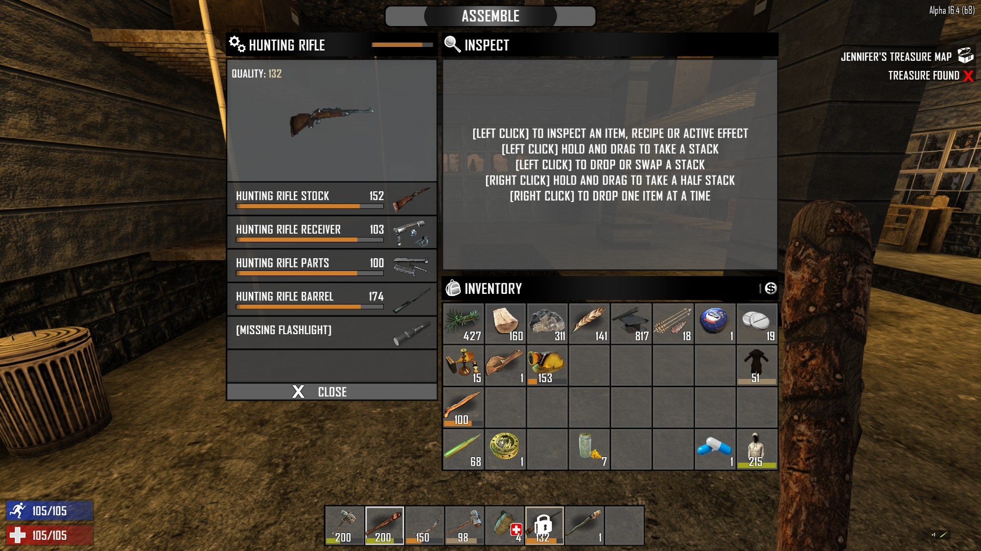

Inventory
While designing the inventory system its important to design it in such a way that it stays at least somewhat close to reality.
Example: objects have not only different weight but also different sizes. A pack of matches does not take up as much space as an assault rifle.
Nice example for an inventorysystem has Neo Scavenger

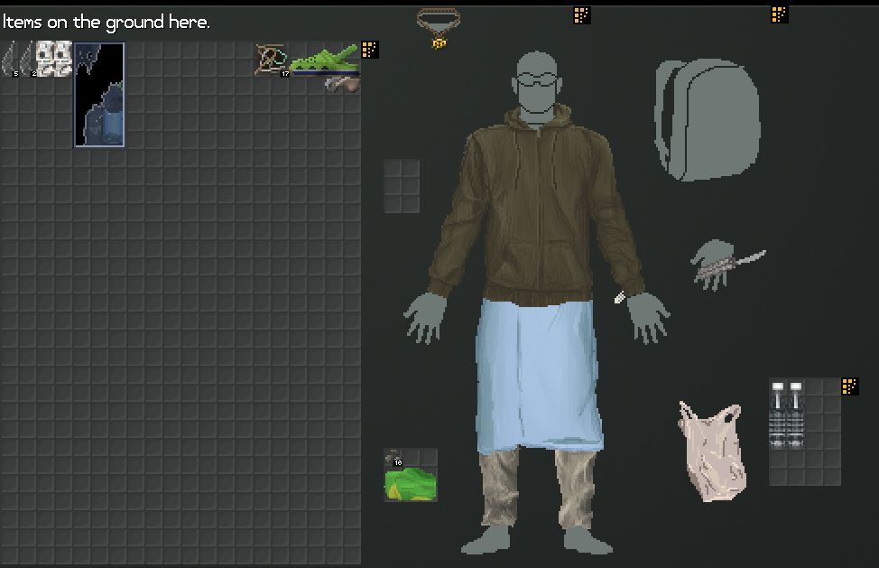
This screenshot shows on the left the ground near the character with everything that is in his reach lying around there. On the right the character is shown with all the slots (the grey squares) he can use to carry items. The hoodie for example provides 6 squares arranged in a 2x3 arrangement. The arrangement is important because, if for example the player found a long pole that is just 6 squares in a row, it would not fit into the hoodie because the arrangement does not match.

Combat
The focus for combat will be on the struggle between the hunted player and his hunters. Since the player starts without any weapons the first combat might be unarmed, later it can turn to melee and then to ranged.
Combat will often be short but very stress inducing and also can be quite deadly, especially once the player is better equipped and able to confront the mercenaries that hunt him.
But even with the best equipment, a lucky shot, punch or stab can be the end, for the player as well as for the NPCs.

Attack and defence

Hit allocation
Once it is clear that an attack connected, its time to find out where it landed.
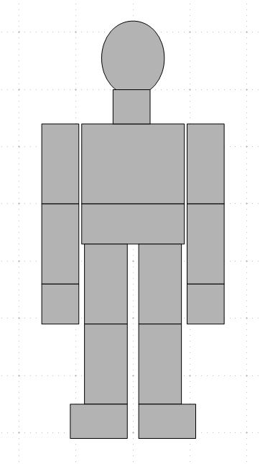

A simple schematic shall be reference here. The bodies of the characters are made up out of the parts shown above:
Head, neck, upper torso, lower torso (includes the hip), upper arms, lower arms, hands, upper leg, lower leg, feet.
Depending on the type of attack and the angle of attack, certain parts of the body are more likely to be hit than others. During a fistfight for example, the parts most likely to be hit are the upper torso, the head and the arms.

Damage
In the game. there are three main types of damage caused by physical objects, blunt, piercing, slashing. In addition, there are two types of damage caused by energy, burning and freezing.
Blunt damage is caused by blunt objects like fists, stones, clubes, and falls. Some types of ammunition can also cause a certain amount of blunt damage.
Piercing damage is caused by pointy objects like needles, knifetips, impalement by for example broken branches and many projectiles.
Slashing damage is caused by sharp objects like blades, claws, broken glass etc.
Burning is caused by absorbing more thermal energy that can be given off, can be caused by sunlight and of course fire.
Freezing results from the thermal energy being drained from the body by the surrounding. Most commonly caused by being in a cold environment for prolonged periods of time. The colder the environment the less time needed for freezing to occur.

Armour
Armour can reduce or even completely negate the damage of an attack. How effective it is in doing so depends on the type of damage and the armour.

Effects and Injuries
The above mentioned different types of damage cause different types of injuries to the human body. But, depending on the amount of damage, more than one type of injurie can be caused.
Blunt damage:
Blunt damage is the best damage to knock a character around because it applies the most force to the body of the target. Low amounts of blunt damage cause painful bruises, higher amounts damage (fracture/break) the bones and rupture/tear the organs. Massive levels can also cause the skin to tear (blood loss) and smash limbs, destroying them in the process with no healing possible. Many armours protect against blunt damage by spreading the energy, rolling with the attack also reduces the amount of damage.
Piercing damage is not very likely to cause the target to stumble or fall because the energy is focused on a small point. Small amounts of piercing damage can cause deep bleeding wounds with a high risk of infections, if the torso is hit they can injure the inner organs.Higher amounts cause two wounds (entry and exit) that increase the amount of bleeding. A hit on the body has the chance to pierce an organ, can also (if lucky) pass through the body without causing much internal damage. Massive amounts will damage/rupture organs for sure and will leave limbs unusable because of torn muscles. Piercing damage is also very effective in piercing armor.

Slashing damage has more effect on the mass of the target but not as much as blunt damage. Low amounts of slashing damage cause bleeding gashes with a rather high blood loss. Higher amounts will damage the muscles as well while still increasing the amount of bleeding. If the torso is hit organs will most likely be hurt as well. Massive amounts can cause limbs to be sheared clean of, destroying them in the process. In case of the torso it means guts spilling out on the ground.
Burning causes extreme pain and stress but does not render the limbs unusable until very high amounts of burning are sustained. One of the problems of burning is the destruction of the skin which will cause huge areas that can become infected. In addition, as soon as armor/clothing is burned through, it does not protect anymore but causes even more damage until it is removed.
Freezing causes much less stress and pain but can render limbs unusable very quickly. But since it is unlikely that our characters will stumble into pools/tanks of liquid oxygen it probably wont happen that such extreme causes of freezing will occur in the game.
Injuries will be shown to the player on a screen he can call up.
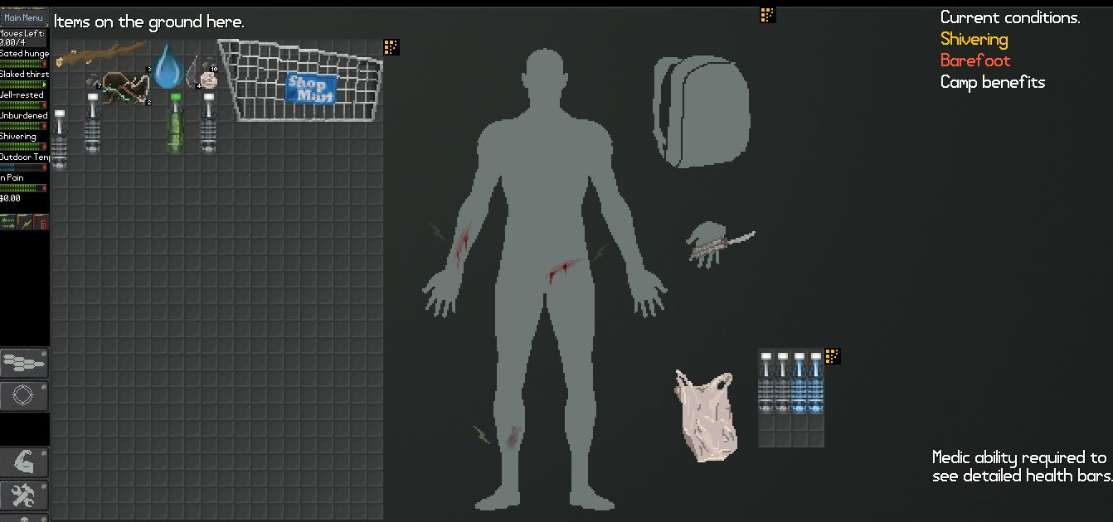
It shows him his body and the region where the injuries are and any details the player can get with his skill in medicine.
Also on this screen he can select how he wants to treat the wound.
Note: Some injuries (like on the back) will require a second person to treat them right. This makes getting some allies extremly important.

Mechanics

Environmental

Day/night cycle
Since the length of day and night varies accordingly to the seasons, they dont have to be of the same length.
First idea: Day 30 minutes, dusk 10, night 10, dawn 10

Heat, cold and humidity
Heat/cold should be handled by a “thermal energy” value of the character. Heat adds to that value, a cold surrounding reduces the value.Thermal energy over a certain value causes burning, below a certain value causes freezing.
Clothing and armour has an insulation value that defines how effect is has on adding/subtracting thermal energy

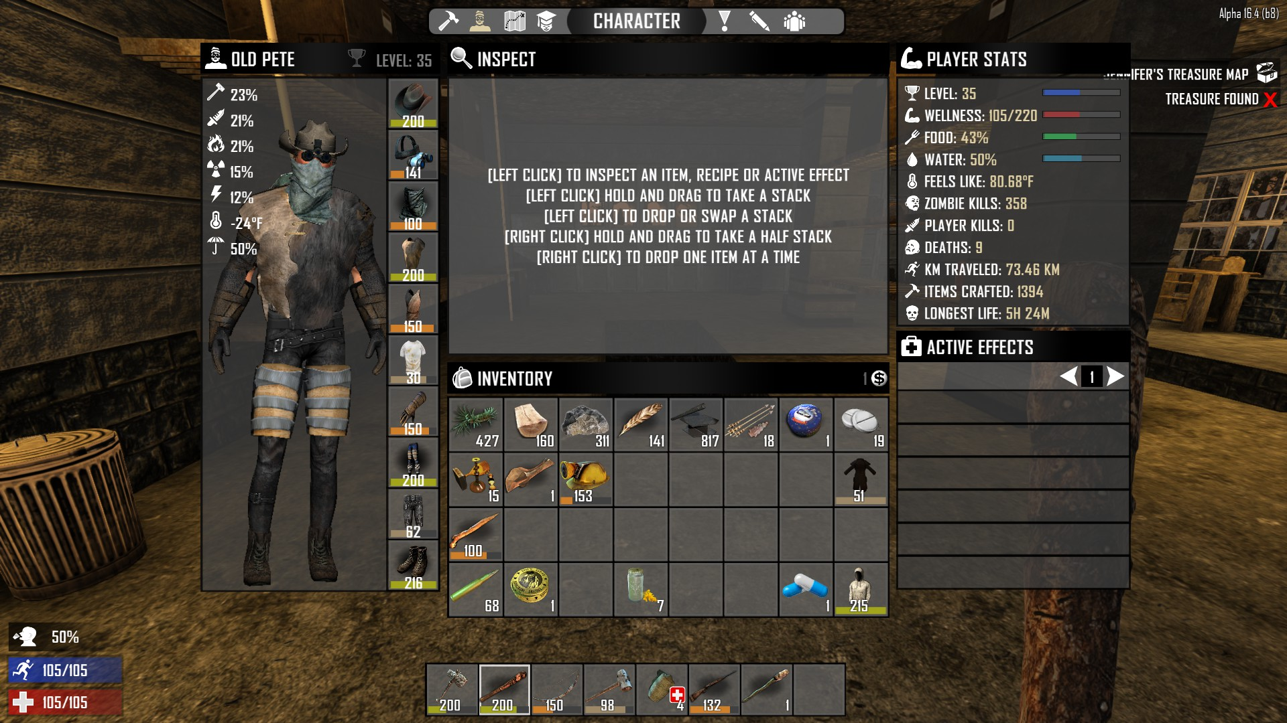

On the left you can see the stats of the gear the character is wearing, the different types of protection it overs and also how well insulated he is. In this case the character is wearing gear that is good against cold, but since he is in a rather warm area he threatens to overheat.

Zones
The gameworld can be build out of zones. Zones have parameters like coverage from light, from rain, distance for line of sight (los), difficulty of the terrain, stresslevel, chance for injurie, chance to find something etc.
Zones:
- flat structure (road): Can be ok, damaged or destroyed
- Non-flat structure (junkyard)
- enclosed structure (building)
- barren earth
- grasland
- tundra
- light forest
- deep forest
- rain forest
- desert
- swamp
- water (has depth)

Example: Deep forest has a high coverage against light and rain, short distance for los, medium difficulty, low chance of injurie, high chance to find leaves and twigs and fruit and medium to high stresslevel
A clearcutting in the forest has zero coverage against rain and light, long distance for los, high difficulty, high chance of injurie, high chance to find pieces of wood and low stress level

Controls

Looking
Mouselook. View should be two cones, starting from the face of the avatar. The central cone delivers the clear picture. The outer cone deliveres the peripheral view.
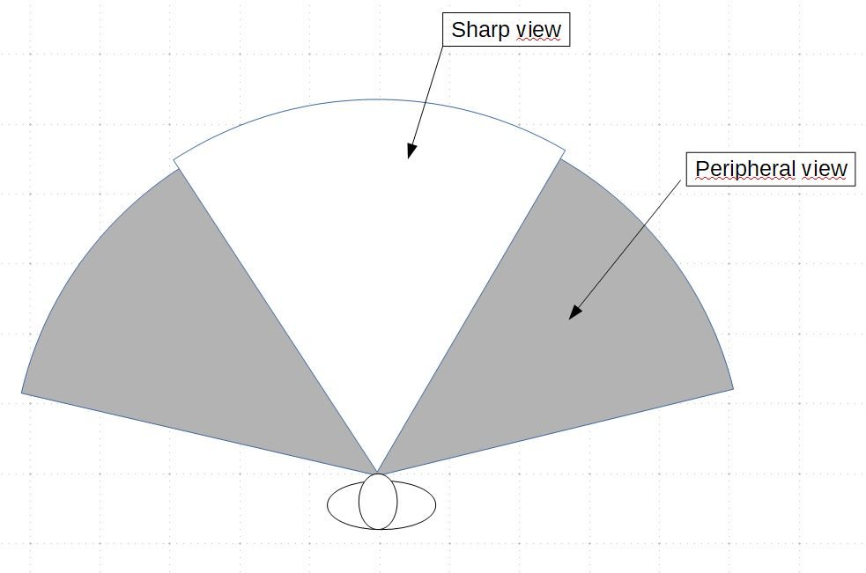

Movement
Normally we move in the same direction we look.
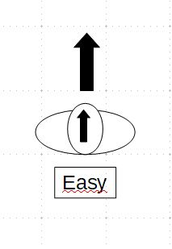
Moving in a direction we are not looking becomes more and more difficult.
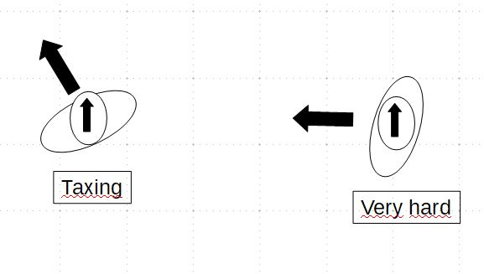

We can make moving that way easier by familiarizing with the terrain.
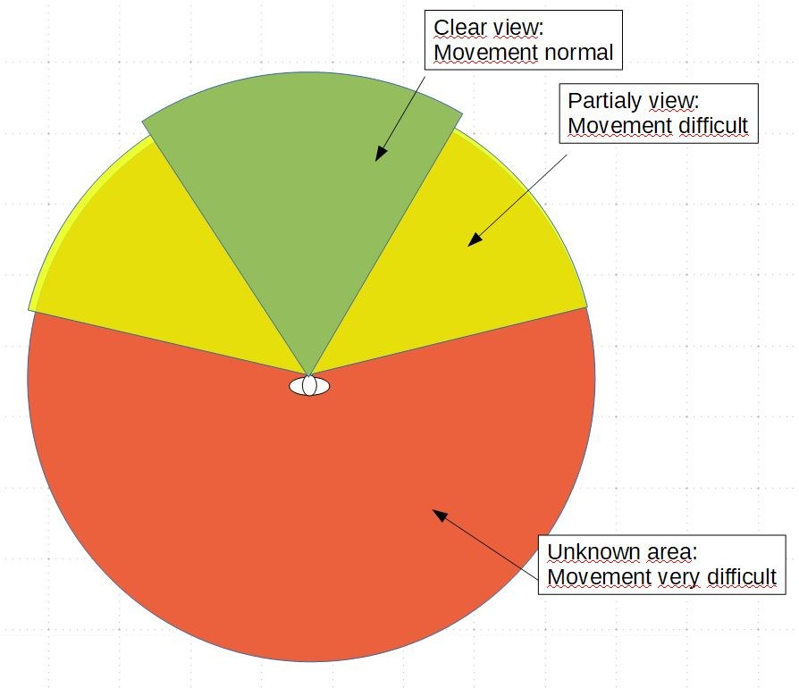

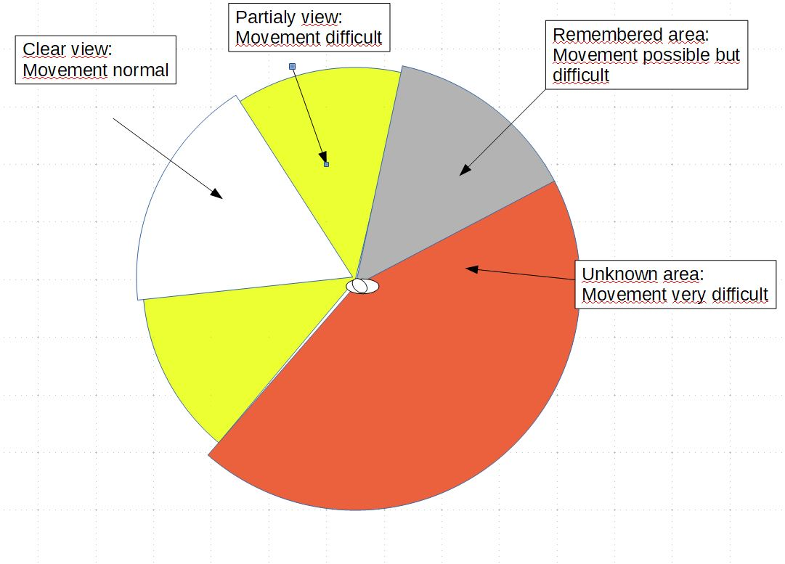

So moving without looking in a completely unfamiliar terrain should be extremely difficult, slow and with high risks of stumbling, making noise, injuries.

Speed, weight and exhaustion

Characters

Parameters
Height: 170 cm +(1-15) -(1-15). Not much influence on the game. Some clothing might not fit if the height differes to much.
Weight: Height-100 -(1-10) +(1-10). Important for the calculation of how much stamina is used while moving fast or climbing, also for acceleration and deceleration.
Stamina: connected to exhaustion. Stamina depletes and regenerates faster, but the more exhausted you are the less max stamina you have.
Example: The avatar runs 100m. At this point his stamina is at 0, overall exhaustion has dropped by a factor x. The avatar rests, his stamina regenerates up to the limit which is determined by his exhaustion. Now he can only run 90m before his stamina is depleted.
Exhaustion(can be musclerelated)
Exhaustion is a factor that is limiting the player more than stamina. Exhaustion can only be reduced by a real rest, sleeping works best.
Tiredness: Increases over time. 100% after 1 day. Can be pushed further but will result in a progressive decrease in efficiency.
Mood: 0 is neutral. Good weather, good food, good loot, having allies increase mood. Bad weather, injuries, bad food, broken items, allies lost or killed decrease mood. High mood = boost to stamina, healing, crafting speed
Hunger: Governed by amount of sugar in the blood. Consuming food will provide sugar, activities drain sugar. High hunger = decrease in stamina, increase in exhaustion, reduced healing
Thirst: Governed by hydration. Drinking and consuming food provide hydration. Heat and activities drain hydration. High thirst = tiredness increase, headache. Can be fatal fast!
Health:

Skills/abilities
Skills and abilities are values that are evaluated in the background while the avatar is doing things. “learning by doing” is a key element in this regard. That is something the game should reflect in its mechanics.
Examples for skills and abilities:
- Athletics:
is related to running, swimming, climbing and controlls how fast the avatar is losing stamina and gaining exhaustion while doing those physical activities)
- Climbing:
the value of this skill is compared to the climbingdifficulty of for example a wall or a tree. If the skill of the avatar is much lower, the climbing is very slow or maybe not possible at all. If on the other hand he is a master climber, climbing is much faster
- medicine:
governs the evaluation of wounds and injuries
- Stealth:
sneaking, moving quietly, the amount of tracks produced, the efficiency of the “remove tracks” action
- Perception: spot tracks, traps, animals, items, rescources, etc.
- Unarmed combat
- Melee combat
- Ranged combat

Learning/adaptation
Humans are excellent at adopting to different situations, given enough time.
Mechanics that can be influenced by learning/adaptaion are crafting, movement, stressresponse and resistance
Example crafting: The first tools the player crafts will be of very low durability and efficienzy. But with each new try they will improve because the character will iron out the flaws and think of new ways to improve them. This will also reduce the time it takes to craft that item.
Example movement: The first time the player moves into a new territory/zone, his movement will be reduced because it is unfamiliar to him. In addition his stress will rise because he is of course aware of the fact that he does not know where he is moving into.
But the longer he stays and the more often he takes that route, the more familiar he will become with the terrain, he will know where to place his feet and thereby increase his speed and reduce the chance of injuries.

Player character
United we stand…
Since the game can and will be very hard on the player, its important to offer ways how the player can keep playing the game even if things dont work out as he has planned them, for example when his character gets hurt or injures himself and it takes a long time to recover.
In such a case it could be an option to allow the player to switch control to an allied character he has rescued already.
From that point on he would control the new character just like he controlled the old one and the old one would become an NCP.

NPCs

Items

Item categories
Clothing
Food
Tools
Junk
Natural resources (Stone, Wood, Grass…)
Artificial Resources (Brick, Nails, Planks…)
Useless/Decoration
Entertainment
Weapons

Item attributes

To establish a somewhat realistic inventory system, items need to have certain attributes
Weight (in gramm/kg. Carrying a heavy weight increases exhaustion fast. If the weight of an object is to high, it can not be moved, even if it is small enough to be picked up in theory.)
Volume (cubiccentimeter)
Fixed Form? (a rifle has a fixed form, a piece of cloth does not)
- Form (height-length-depth) in cm
Handles? (a suitcase normaly has one, a cooking pot 2 (so two hands can be used to lift), a crate has none)
- Number of handles
Slingable? (has a sling so can be worn over the shoulder. Slings can be attached to many items just by tying a rope to them)
Splitable? (is it a stack of items?)
Stackable? (is it an item that can be stacked? Nails can be stacked, assaultrifles cant)
Breakable? (can it be broken?)
Consumable? (can it be consumed in any way? Not only applies to food, a can of oil can be drunk too...)
Condition (how good is its condition? Lower condition means lower efficiency)
Repairable? (can its condition be restored?)
Energy transfer ratio (concernes mostly clothing, the amount of energy transfer the item encourages or blocks)
Is container? (can be stuff put into the item?)
- inner volume
Closable? (if its a container, can that container be closed/sealed?)
Spoilrate (how fast does its condition drop if left alone? Food mostly)
Hardness (how much slashing damage does it block?)
Damping value (how much blunt damage does it block?)
Densness (how much piercing damage does it block?)
Can be dissembled? (rifle for example)
Is part of (a barrel is the part of a rifle)
Flamable? (if thermal energy is high enough will the item start to burn?)
- Burnratio (how fast will its condition drop if its on fire?)
Hookable? (can it be worn on a hook? Hooks can be attached to some items)

crafting, assembling, disassembling, upgrading

Inventory
Slots:
Shoulders
Hands
Bags
Pockets
Backpacks
Containers

Combat
As mentioned above, combat is a brutal business which can result in injuries or death for the participants. To simulate such a life and death situation, we first need to look at how combatants can attack and defend. Then we will see what damage a successful attack can cause. After that we describe the effects the different types of damage can have.
Keypress (Key?) to switch between normal and combat mode. Toggle.

[Screenshots from Life is Feudal]

Attack
Left mouse click: Attack with left hand
Right mouse click: Attack with right hand
Click causes character to try to connect hand or handheld object with target. Target = focus of view.
Buttondown = Character starts to pull back fist/object. First hand + arm, than shoulder, than upper body.
ButtonUp = Hand moves towards target, energy = speed (muscle groups involved) + mass (object + bodyparts involved)
Precision of movement depends on Skill (Melee).

Defense
In Combatmode with key (?) pressed, character is in defense mode. Like the guard up with boxers. While the button is just pressed, view and body orientation are looked, the character always turns in the direction he is looking.
Turning that way is slower then just with mouselook.
In defense mode, clicking the mouse will cause the character to try to deflect an incoming attack by moving his hand/object in the way of the incoming object. A successful deflect can open the attacker up for a counter attack.

Game structure

Success and motivation
During the game there should be a progression of steps of success which the player can achieve. Since the overall goal (being? Save your friends and escape? Kill the bad guy? Call in help?) is of course not easy to achieve, its important to give the player other things he can achieve to keep him motivated
Example
- Step 0: the player is on the run, his pursuers hard on his heels through the jungle.
Goal: lose the pursuers
- Step 1:The hunters have given up (for the moment), the player is alone in the jungle.
Goal: find any sort of shelter
- Step 2: The player has found a nice spot for his first basecamp. Might be spot of flat ground near a lake/river, a rock, tree with clear ground beneath. There he gathers himself, checks what he has and what can be found in the immediat vicinity. It should become clear that, if he stays there for long, he will either be found or the environment will kill him.
Goal: learn the basics of survival and crafting to prepare for a search for a better spot
- Step 3: Equipped with primitiv gear and eating raw stuff to stay alive, the player starts to explore the surrounding jungle, looking for a spot that a) is better hidden and b) offeres better protection from the elements and options to set up more permanent utilities. Examples: a have in a mountainside, a group of tress to build a treehouse, a dead, hollow tree. To be able to use these the player must complete a simple task, like make a torch to scare some animals out of the cave or make a rope to climb up a tree.
Goal: find the spot for a permanent base and “unlock” it
- Step 4:The player has achieve his first bigger success, he has found a place that not only hides him well from detection (unless he makes lots of noise and such of course), it also has valuable resources nearby (water for example) and offers good shelter from rain, heat, cold, animals and other dangers.
Goal: set up all the utilities that are needed for basic survival, a permanent fireplace, a place to sleep, something to collect water, to prepare food, to warm up, to store stuff
- Step 5: The base is established and the player no longer needs to worry all the time about his basic needs like food, water, shelter and sleep
Goal: Now is the time to realy think about ways how to confront the mercenaries, get intel, spy on them, help your friends…

That is just the basic structure. The is an option for a twist that can, if implemented right, be rather entertaining:
The player knows that his friends are in danger. So he does not have all the time to focus on his own struggle, he propably will try to do something about them without being totally prepared. This may result in the following scenario:
The player has achieved step 3, but instead of looking for good shelter he uses his basic gear to head out for the camp of the mercenaries. He spots one of his friends doing some labor, not well guarded. He sneaks in, rescues him, maybe even manages to gather some gear before they are being detected. They have to flee (going back to step 0 of the ladder again).
Now the cycle resets, with a few twists:
a) the AI now knows the player is still alive, what his goals are and that he is somewhat equipped. So they will search now more aggresivly, maybe resulting in the player needing to abandon his first base
b) the player has all the knowledge he already optained + maybe some new gear
c) the players now has an ally who might help him
This cycle can be done a number of times. The next friend will already be guarded better and closer to the central camp but the player is a bit better prepared now + has help maybe. A scenario for the end might be that the player with a small band of poorly equipped followers need to free the last hostage against an enemy that is still more powerful but already weakened too.

